Supplementary figure 1.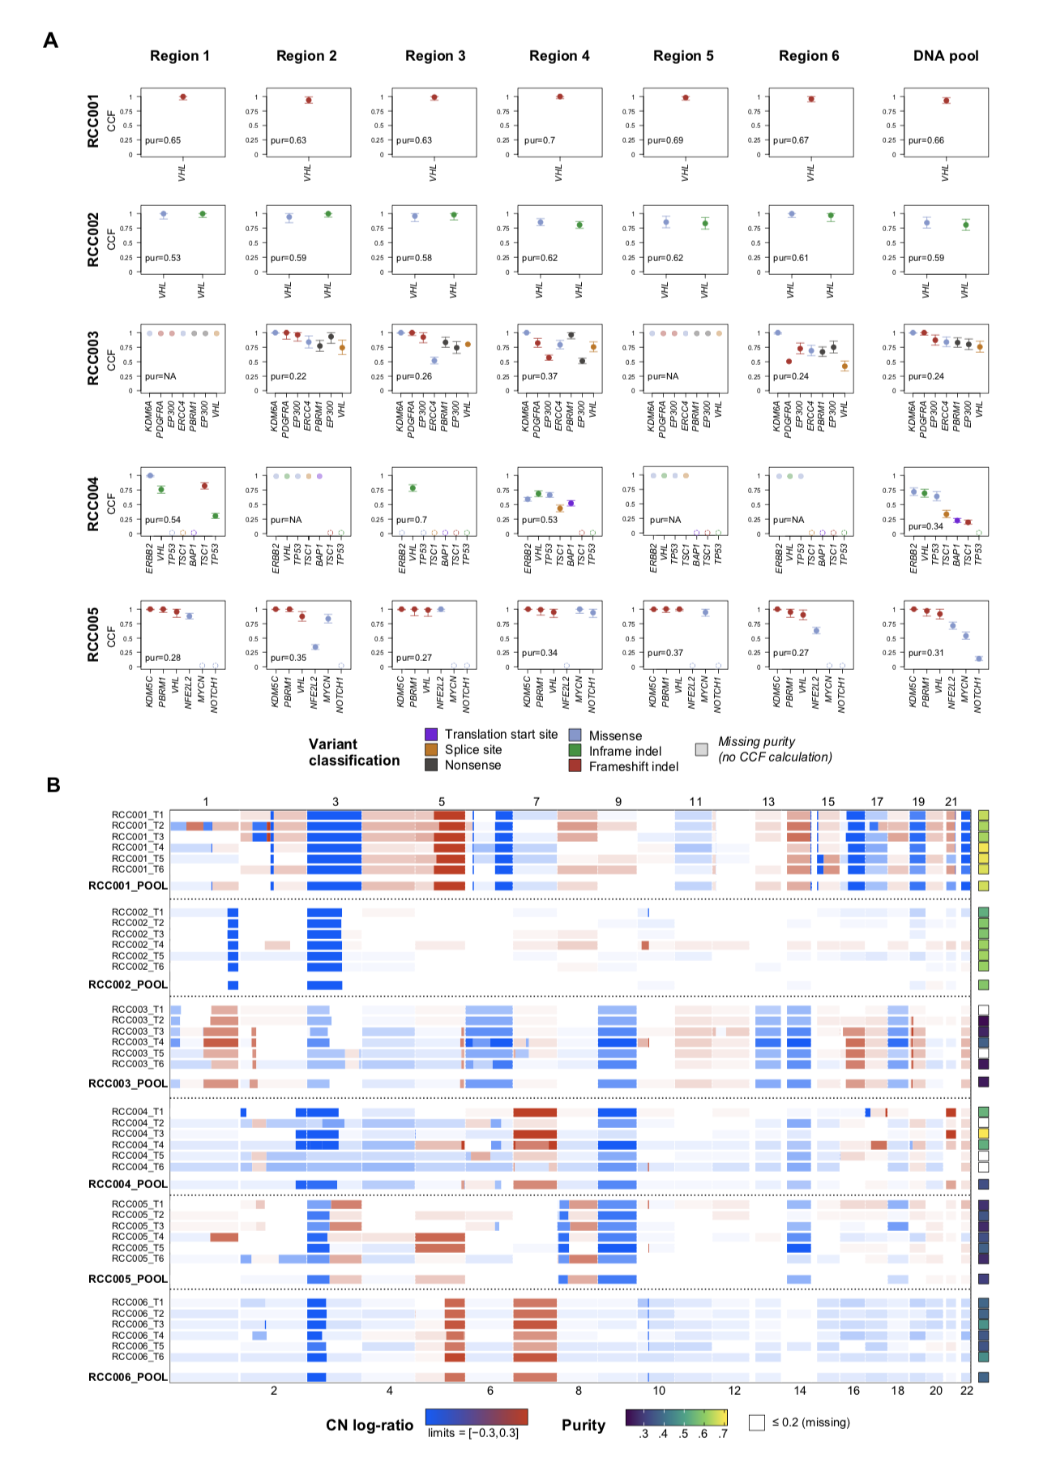
Supplementary figure 1. Detailed mutation and copy-number calls seen in the samples profiled. A. Mutation cancer-cell fraction (CCF) estimates in each of the tumor samples sequenced. Six spatially-separated regions and a DNA pool were profiled for each tumor, and no mutations were detected in any of the samples from RCC006 (not shown). In samples where purity could not be estimated, the variants detected are shown at CCF=1 (dimmed out). Mutations that were not detected are shown at CCF=0 (dashed circles). B.Multi-regional and pooled copy-number (CN) profiles observed in the different samples. The heatmap shows the gains (red) and losses (blue) evidenced across the genome of each tumor region. The tiles on the right represent the purity calculated in each sample. Purity values below 20% are not estimated by the algorithm and appear as missing (white).
Supplementary figure 2
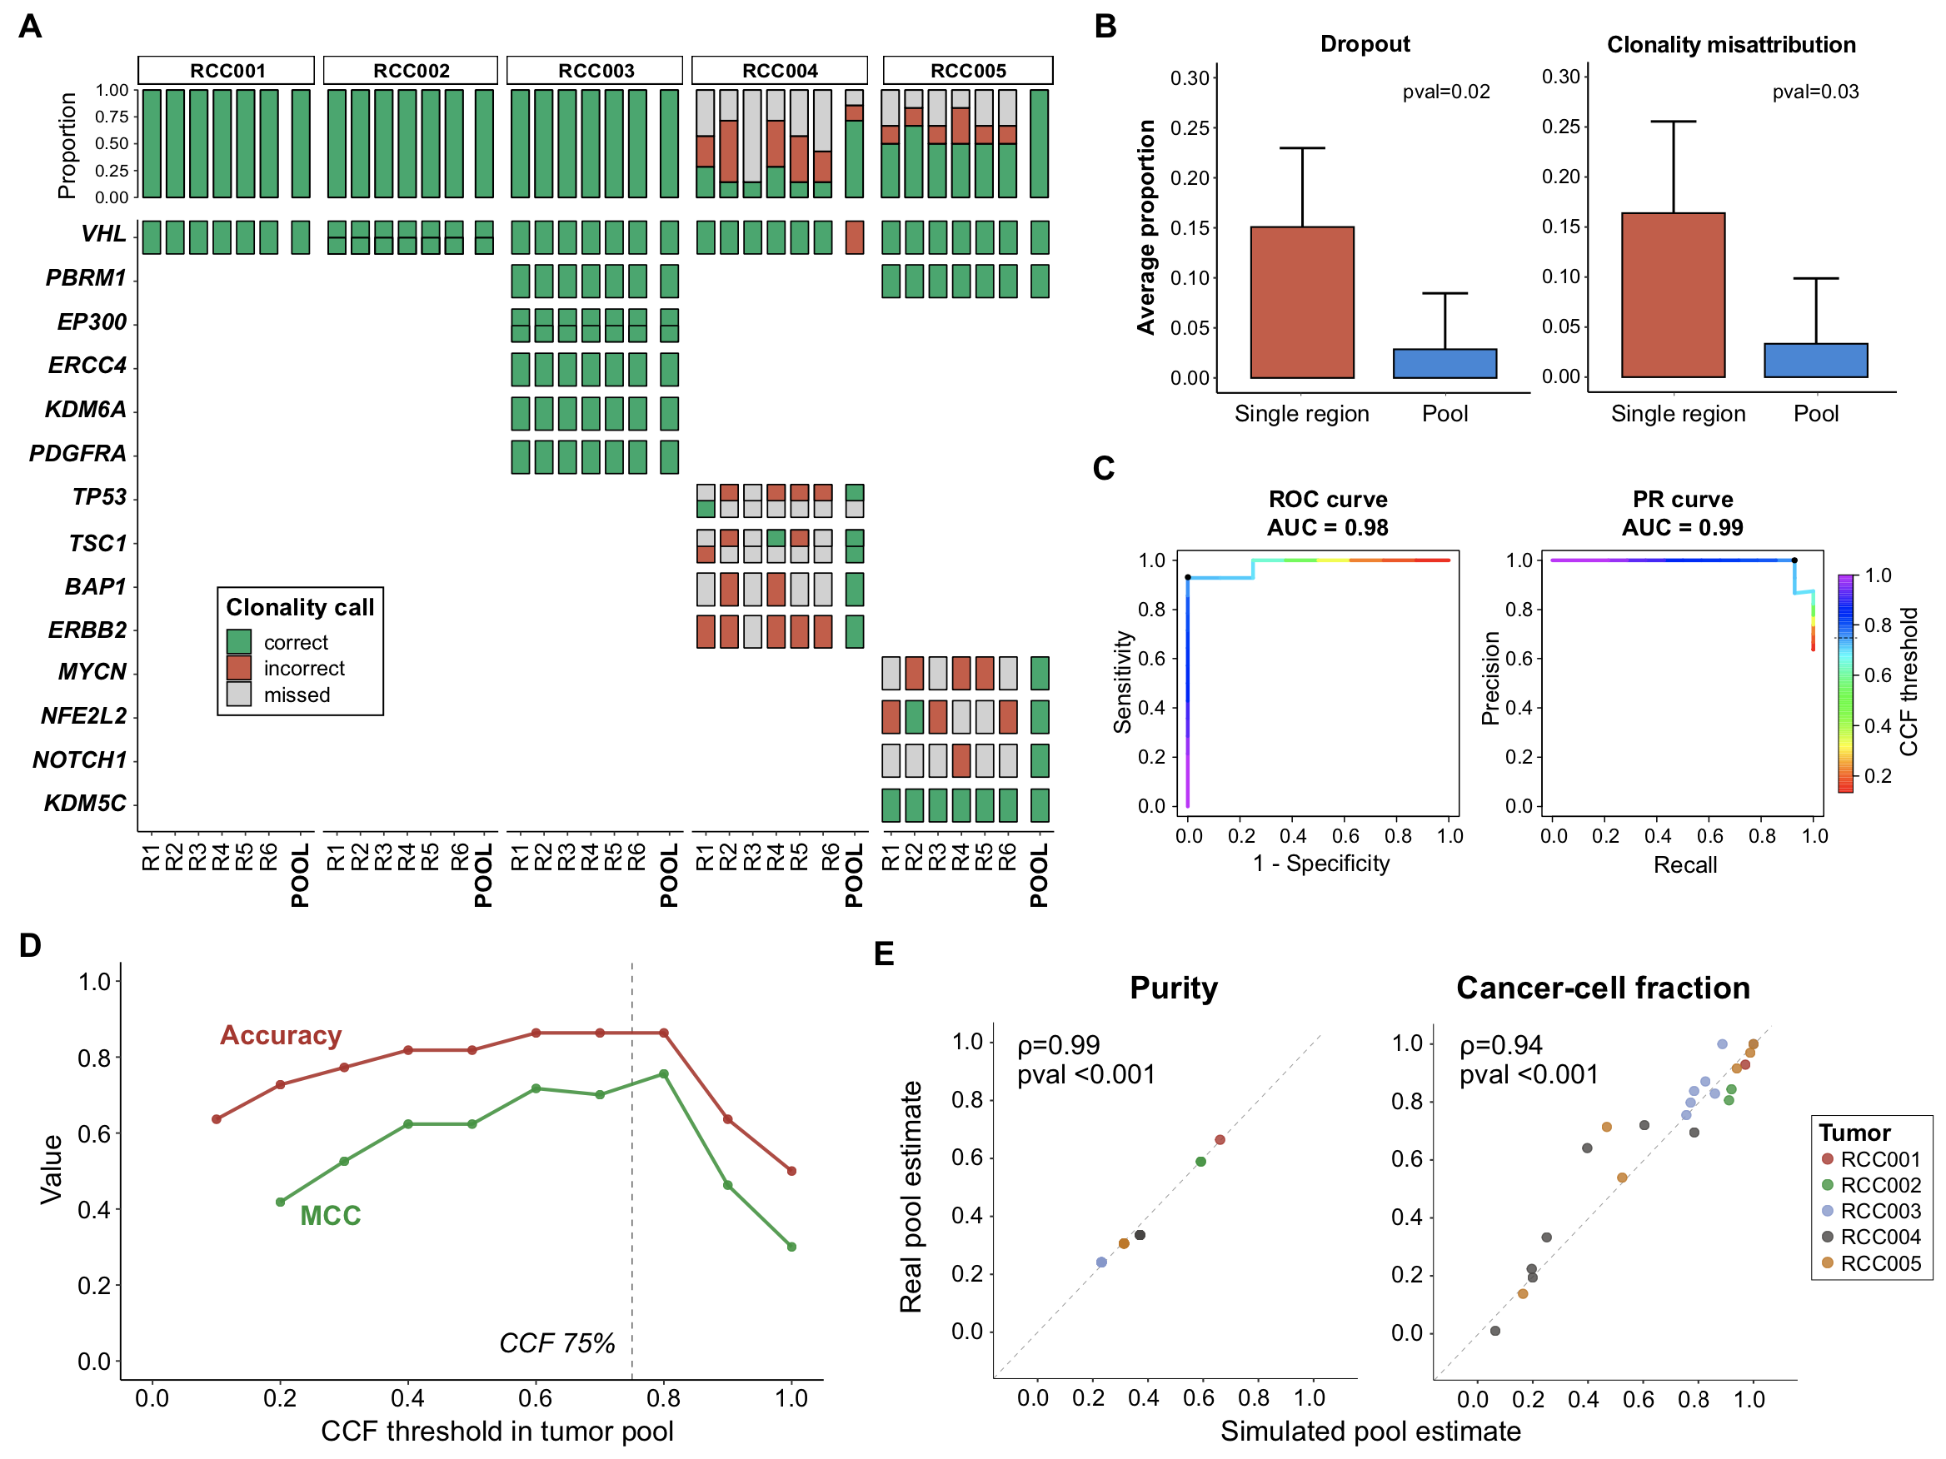
Supplementary figure 2. Comparison of mutation dropout and clonality misattribution between pooled and single-region sequencing using targeted sequencing. A. Oncoprint showing the nonsynonymous variants identified in the samples (N=23). The color of the tiles represent the concordance (green) or discordance (red) between the true clonality status (from assessment of all the regions individually) and the assertion made based on evaluating each sample individually (MR threshold: 0.5, POOL threshold: 0.75, see Methods, Clonality assessment). Samples not detected are shown in grey. B. Average proportion of variants dropped (left) and misclassified (right) in the samples profiled, comparing tumor DNA pools and single regions. Significant differences (Welch’s two-sample t-test) were observed with both outcome measures. C. Receiver-operating characteristic (ROC) and precision-recall (PR) curves to classify mutation clonality using the CCF values in confected DNA pools. The line colors represent the CCF threshold. The color of the lines represents the CCF range and the black dots represent the threshold used to define clonality in the study. D. Performance of tumor DNA pools to attribute mutation clonality across the range of all possible CCF thresholds. Colored lines represent different classifier performance measures (accuracy and MCC). The dashed line represents the threshold of 75% CCF used in the study. E. Observed versus predicted cell-abundance estimates. The purity (left) and cancer-cell fraction (CCF, right) values from the confected DNA pools are compared to those estimated by assessing multiple separate regions (Spearman-rank correlation test). CCF: cancer-cell fraction, MCC: Matthew’s correlation coefficient.

Supplementary figure 3 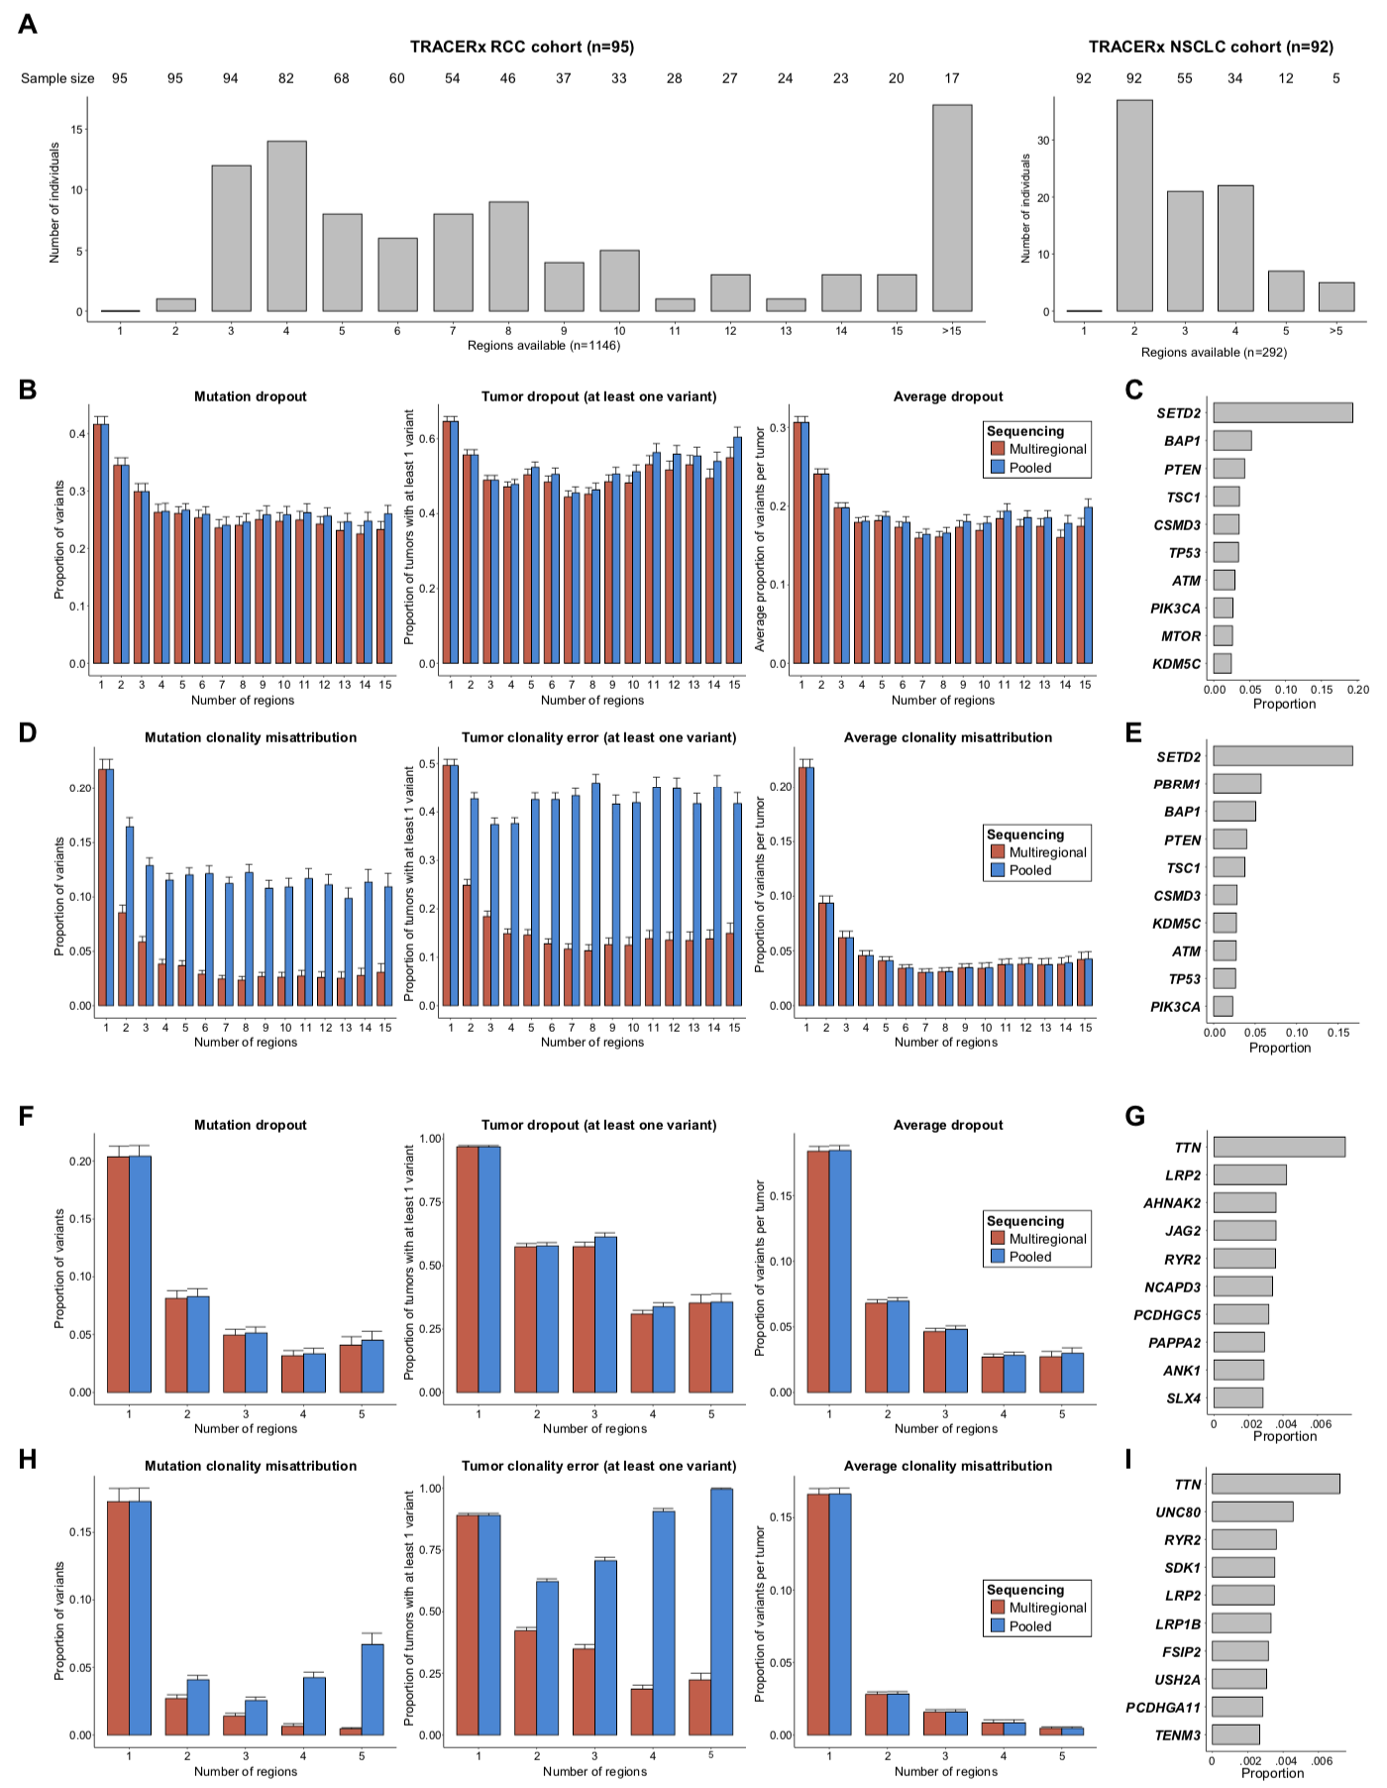

Supplementary figure 3. Dropout and clonality misattribution outcomes in the TRACERx cohorts. A.Number of individuals included in the analysis by regions available. Results are shown separately for the RCC (left) and NSCLC (right) cohorts. Numbers at the top represent the total number of tumors with at least x regions that were used to calculate sample sizes in the bootstrapping approach. B. Mutation dropout in the RCC cohort. Three separate outcomes are listed (for B,D,F,H): total proportion of variants dropped (left), total proportion of patients with at least one variant dropped (middle), and average proportion of variants dropped per tumor (right). Red and blue bars represent the average estimates (over 100 bootstrapping iterations) and the error bars their 95% CI. C. Top 10 genes dropped across 100 simulated pools of 4 regions. Results are expressed relative to all the variants dropped. D. Clonality misattribution in the RCC cohort. E. Top 10 genes misclassified across 100 simulated pools of 4 regions. Results are expressed relative to all the variants misclassified. F. Mutation dropout in the NSCLC cohort. G. Top 10 genes dropped across 100 simulated pools of 4 regions. Results are expressed relative to all the variants dropped. H. Clonality misattribution in the NSCLC cohort. I. Top 10 genes misclassified across all simulated pools of 4 regions. Results are expressed relative to all the variants misclassified.

Supplementary figure 4
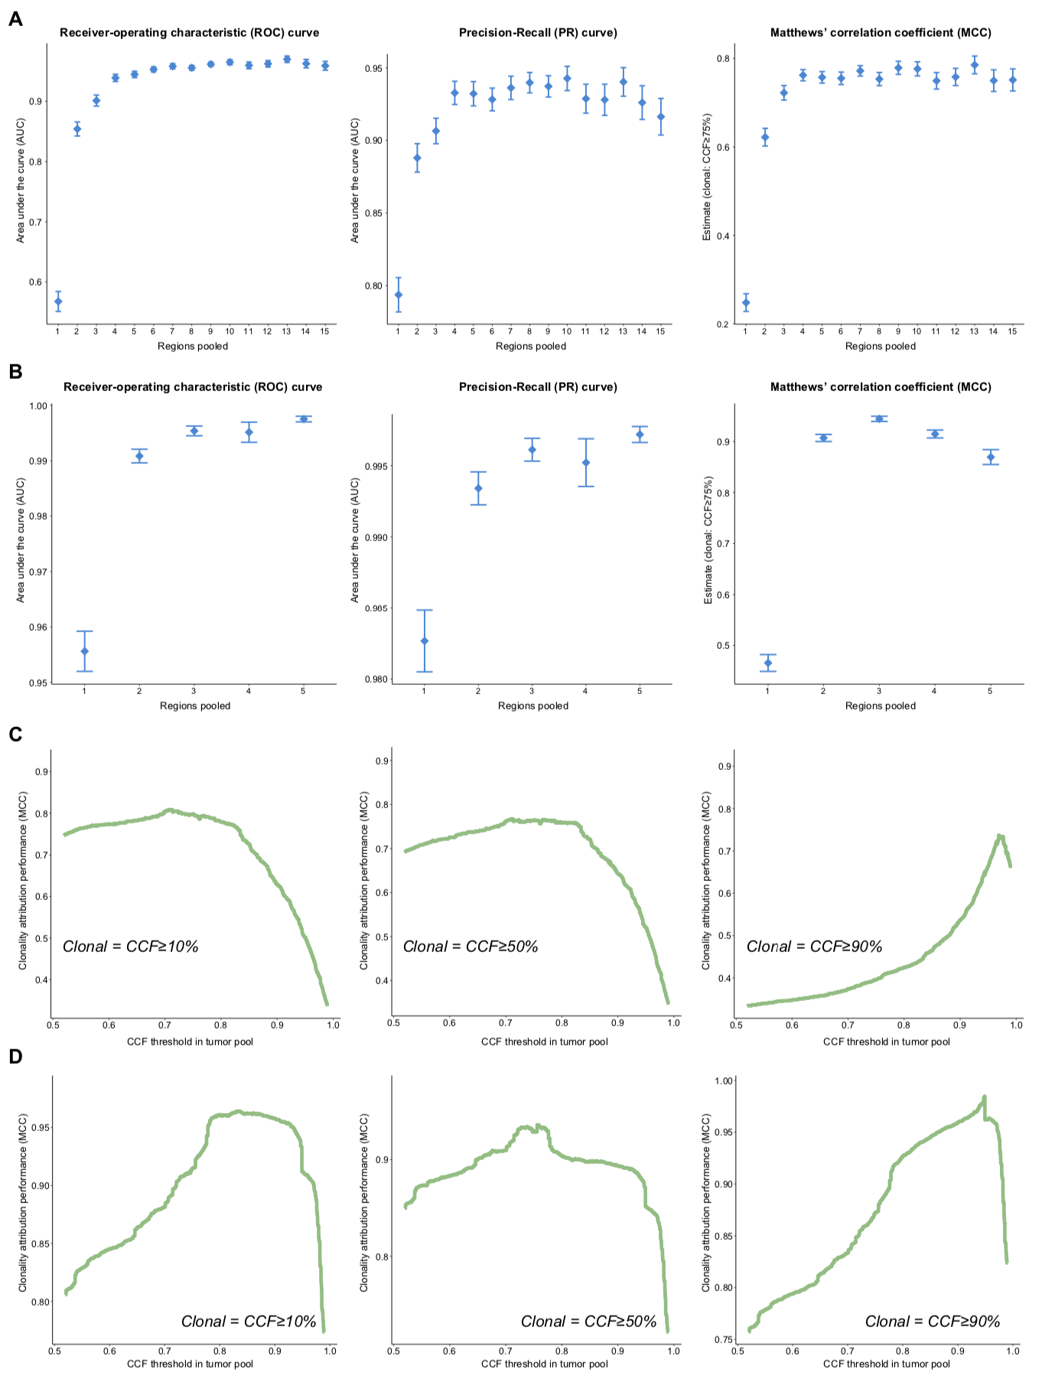
Supplementary figure 4. Performance of pooled sequencing CCF estimates to attribute mutation clonality. A. Binary classifier performance by number of regions in the RCC cohort. Area under the curve estimates for the ROC curve (left) and PR curve (middle), as well as the MCC (right), are shown. The MCC was calculated using a CCF threshold of 0.75. Average estimates (across 100 bootstrapping iterations) along with their 95% confidence intervals are shown. B. Binary classifier performance by number of regions pooled in the NSCLC cohort (as above, A). This cohort had a lower number of regions overall. C. Pooled CCF estimate performance with different definitions of ‘true clonality’. Average MCC estimates from all simulated pools of 4 regions are shown. Each panel represents a different CCF threshold used to define true clonality with all the regions available(shown in italics). Clonal variants were defined as those present in every region at a CCF equal or higher to that threshold. D. CCF estimates performance in the NSCLC cohort (as above, C). ROC: Receiver-Operating Characteristic, MCC: Matthews’ Correlation Coefficient, PR: Precision-Recall curve, RCC: renal cell carcinoma, NSCLC: non-small-cell lung cancer, CCF: cancer-cell fraction.

Supplementary figure 5
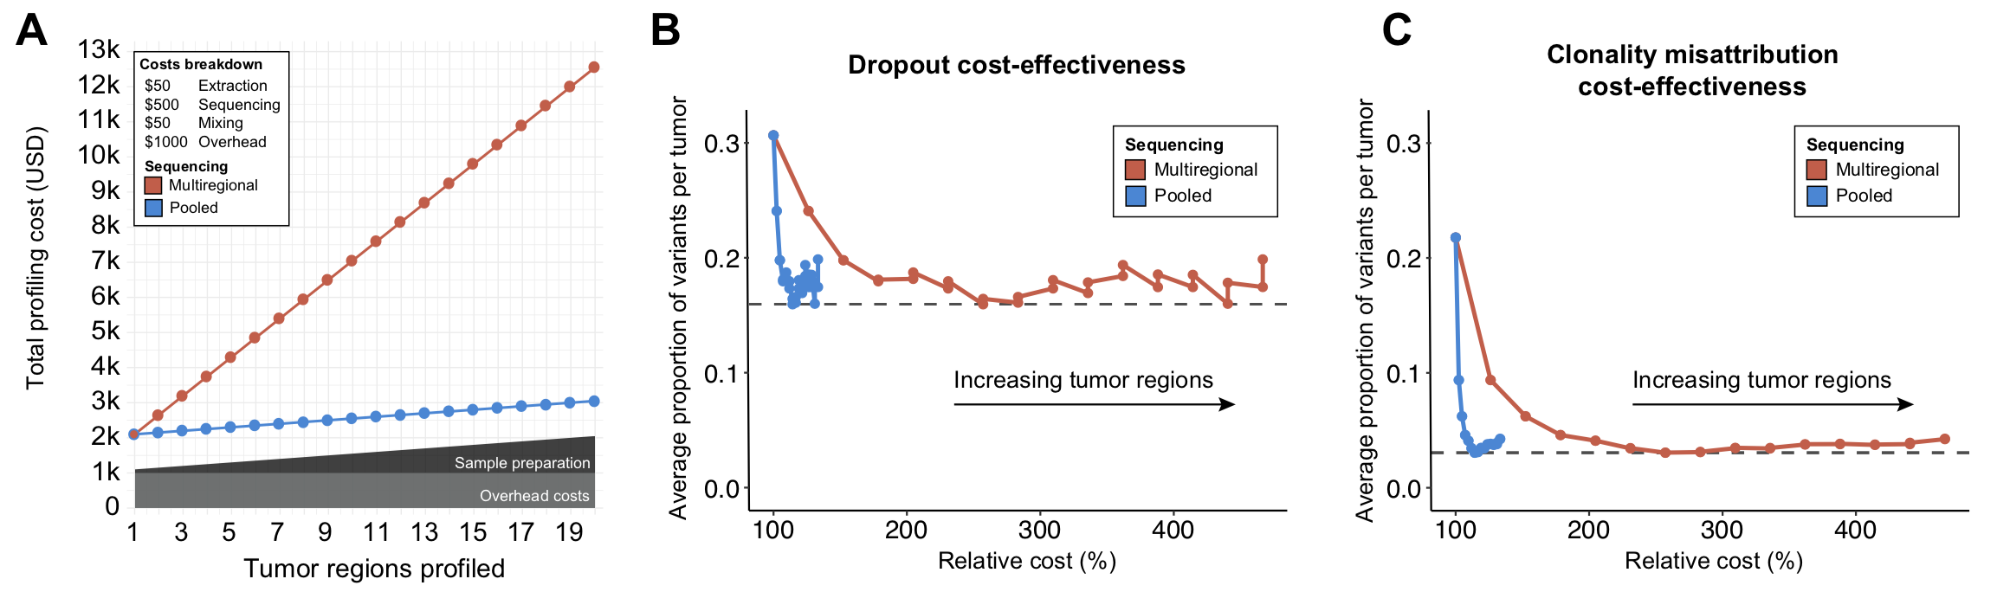

Supplementary figure 5. Cost-effectiveness of pooled and multi-regional sequencing with increasing tumor regions. A. Total costs of profiling with different sequencing strategies. Results are broken down by expense and shown in absolute numbers (1000 USD = 1k). A. Average dropout rate per tumor and cost increments relative to single-regions. B. Average clonality misattribution rate per tumor and r cost increments relative to single-regions.

